|  |  |
| --- | --- |
| **Date:** | 27/08/19 |
| **Time:** | 1900-2030 |
| **Venue:** | SIS SR 2.7 |
|  |  |
| **Attendees:** | All members |
|  |  |
| **Agenda:** | 1. Project orientation  2. Team Introduction  3. Consolidating questions to research by next meeting |

**Discussion Points:**

* Settled weekly meeting timings (Weekly Monday 12-3)
* Settled progress flow of project (skeletal, no additional features)

|  |  |  |  |
| --- | --- | --- | --- |
|  |  |  | **Due Date** |
| 1 | Content to read up/revise on (Coding Frameworks, JSON, Revise PHP, Website Architecture, Bootstrapping) | All | 2nd Sept / 9th Sept |
| 2 | Research how to approach project (eg front and back end at same time) or look for most optimal way | All | 2nd sept |
| 3 | Download Github desktop, signup for Trello | All | 30th Aug |
|  |  |  |  |

**Appendix:**

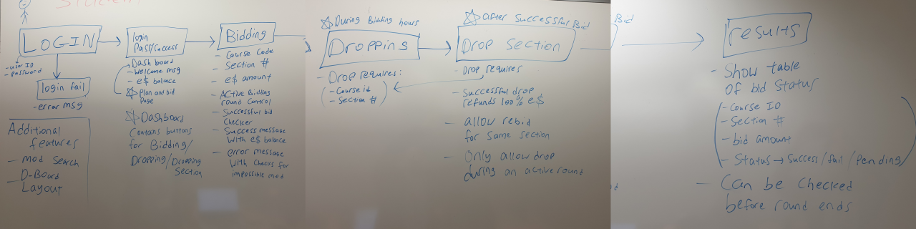

Progress Flow (Student)

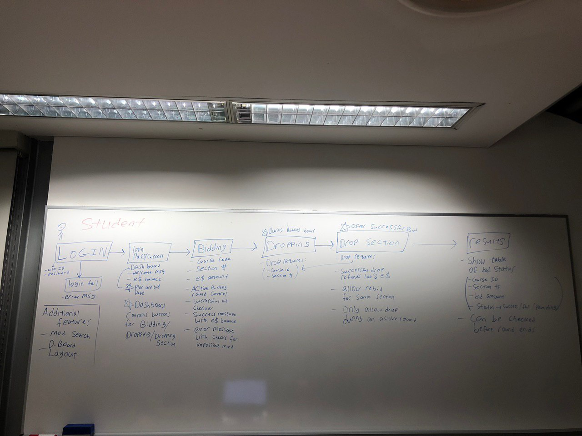

Progress Flow (Admin)

The meeting was adjourned at 8.30pm. These minutes will be circulated and adopted if there are no amendments reported in the next three days.

Prepared by,

Looi James

Vetted and edited by,

Megan Sim